**Joint Network Secretariat (JNS) issues long term mitigation measures on broken wheels**

**20Dec**2019

The Joint Network Secretariat (JNS) has issued the Final Output containing long-term measures aimed at preventing broken wheels of tread braked freight wagons in an efficient and sustainable way. Concerned wheel types are: BA004 and BA314/ZDB29 (with a slope under the wheel flange).

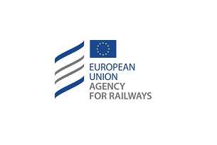

After having developed the short-term risk mitigation measures in 2017 (under a JNS Urgent Procedure), the Task Force, chaired by the Agency and composed of experts from the European railway sector and authorities, continued working and performed an in-depth analysis.

The new measures, [available here](https://www.era.europa.eu/activities/joint-network-secretariat_en), replace the short-term risk mitigation measures and target as well the thermal overload and the minimum wheel diameter. Furthermore, the long-term measures contain proposals for updating the standards, regulations and contractual arrangements.

The Task Force has requested to continue working in 2020 with the assistance of the Agency, and will convene at a reduced pace to

* exchange of information between all sector partners including the Agency and the National Safety Authorities
* monitor the status of the implementation of the long-term measures
* analyse new cases collected

For further information, please [contact us](mailto:https://www.era.europa.eu/can-we-help-you/contact-us-0_en).